Recipe App

* App containing a collection of recipes (entered by a user) which can be selected for an entire week or randomly generate a meal plan for the week and generate a shopping list based on the recipes. Finally send a pdf of the list to a user’s email address to be accessed on phone and downloaded.
* Ingredients should round up or down to the nearest usual unit size for foods, e.g., round from 350g to 500g, 800g to 1kg, etc.
* Auto Generating a weekly meal plan should allow for a set number of dishes to be chosen regarding main ingredient (meat, poultry, vegetarian, pasta). E.g., At least 3 vegetarian dishes in the week. Only 2 dishes which use chicken. Do not put two pasta dishes after one another.
* Measurement of cups to grams convertor for list
* Time measurement – Quick, medium, long. Adjust weekly meal plan by time. E.g., 2 quick meals, 4 medium, 1 long. If not selected just choose from other modifiers or at random.
* Ingredients and Recipes added to database. Recipe can be selected from dropdown box and will add to shopping list.

Recipe Entry:

|  |  |  |
| --- | --- | --- |
| **Name** | **Main Ingredient** | **Time** |
| Spaghetti Bolognese | Meat/Pasta | Medium |

Ingredient Entry:

|  |  |  |  |  |
| --- | --- | --- | --- | --- |
| **Ingredient** | **Weight** | **Unit Sizes** | **Type** | **Main\*** |
| Beef Mince | 500g | 250g, 500g, 1kg | Meat | True |
| Spaghetti | 300g | 500g, 1kg, 1.5kg | Pasta | True |
| Tinned Tomato | 400g | 400g | Vegetable | False |

**Database Types**

|  |  |
| --- | --- |
| ***Recipe DB*** | **Types** |
| Name | Text |
| Main Ingredient | Text |
| Time | Text |
| **Ingredient DB** | |
| Ingredient | Text |
| Weight | Integer |
| Unit Size | Integer |
| Type | Text |
| Main | Boolean |

Example Statement:

*If (WeeklyPlan.IngrType(Poultry) > 3) {*

*RandSelectNewMeal(Vegetarian, Pasta, Meat)}*

*}*

List Generation:

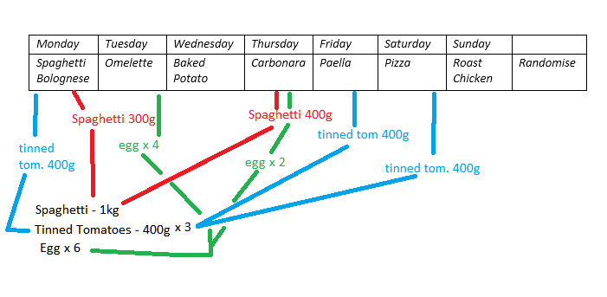

* 300g + 400g spaghetti Rounds UP to 1kg as it is the closest unit size.
* Unit Size of Tinned Tom. Is 400g only, therefor, 400g x 2
* Egg unit size – 6, 12